Integration of Docker Image to Amazon Elastic Container Service & AWS Elastic Container Repository

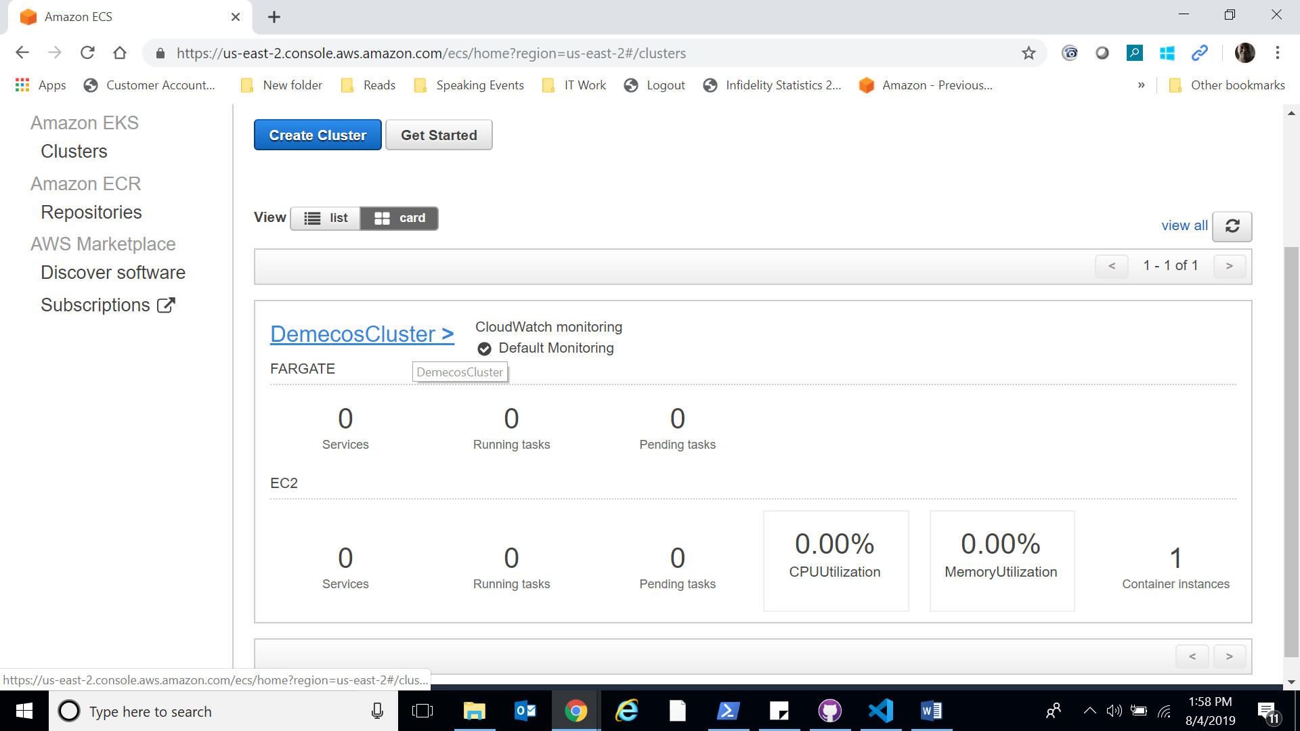

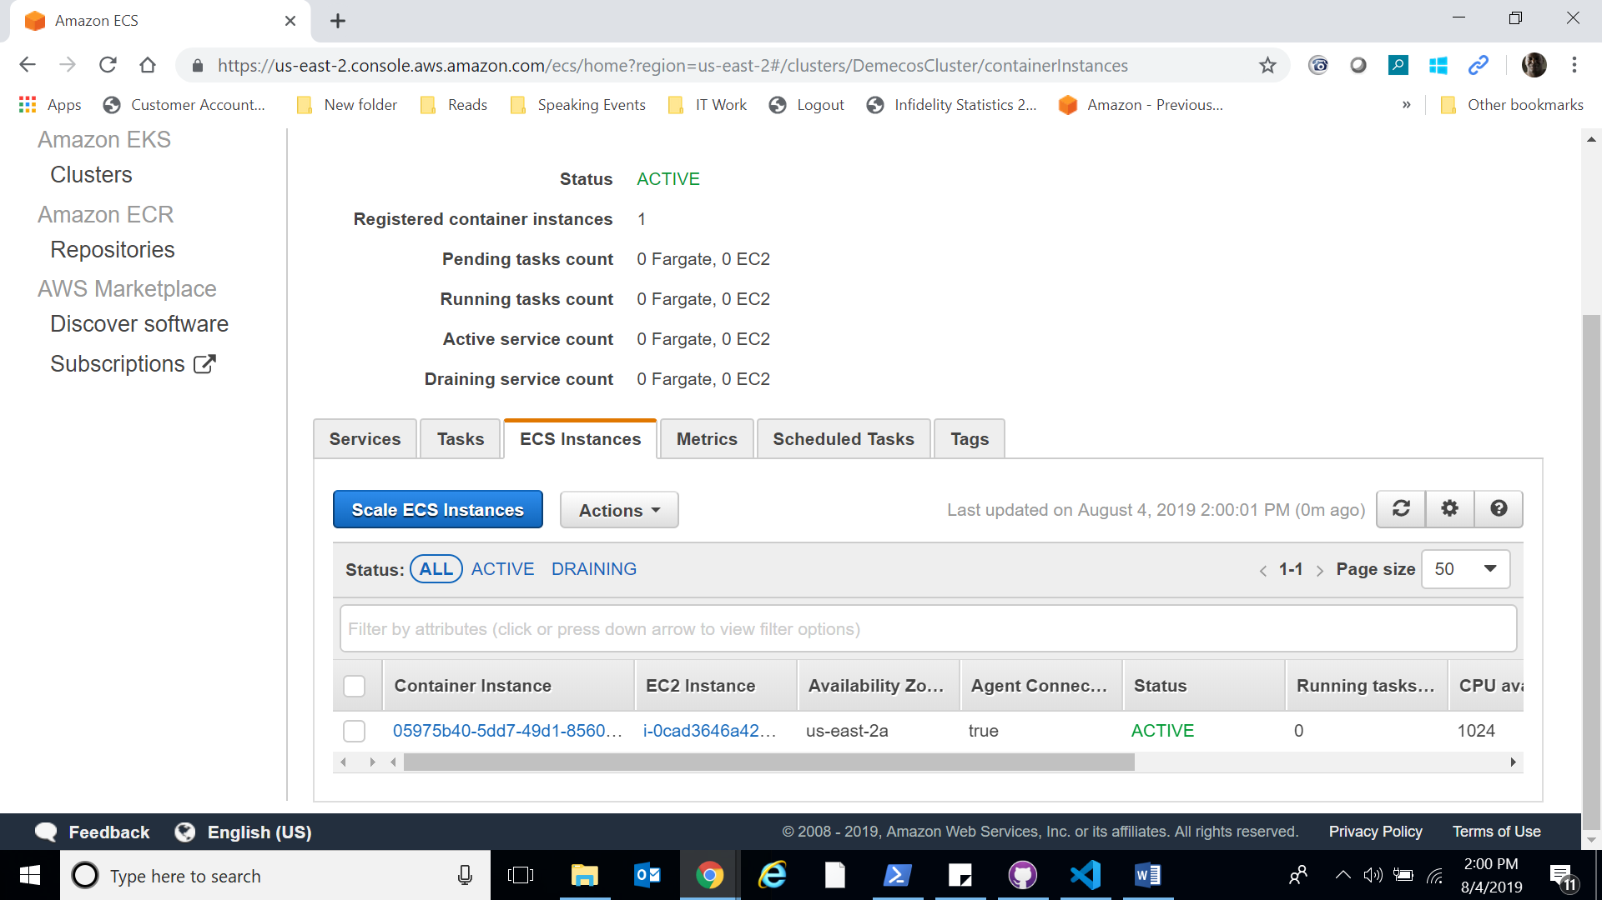

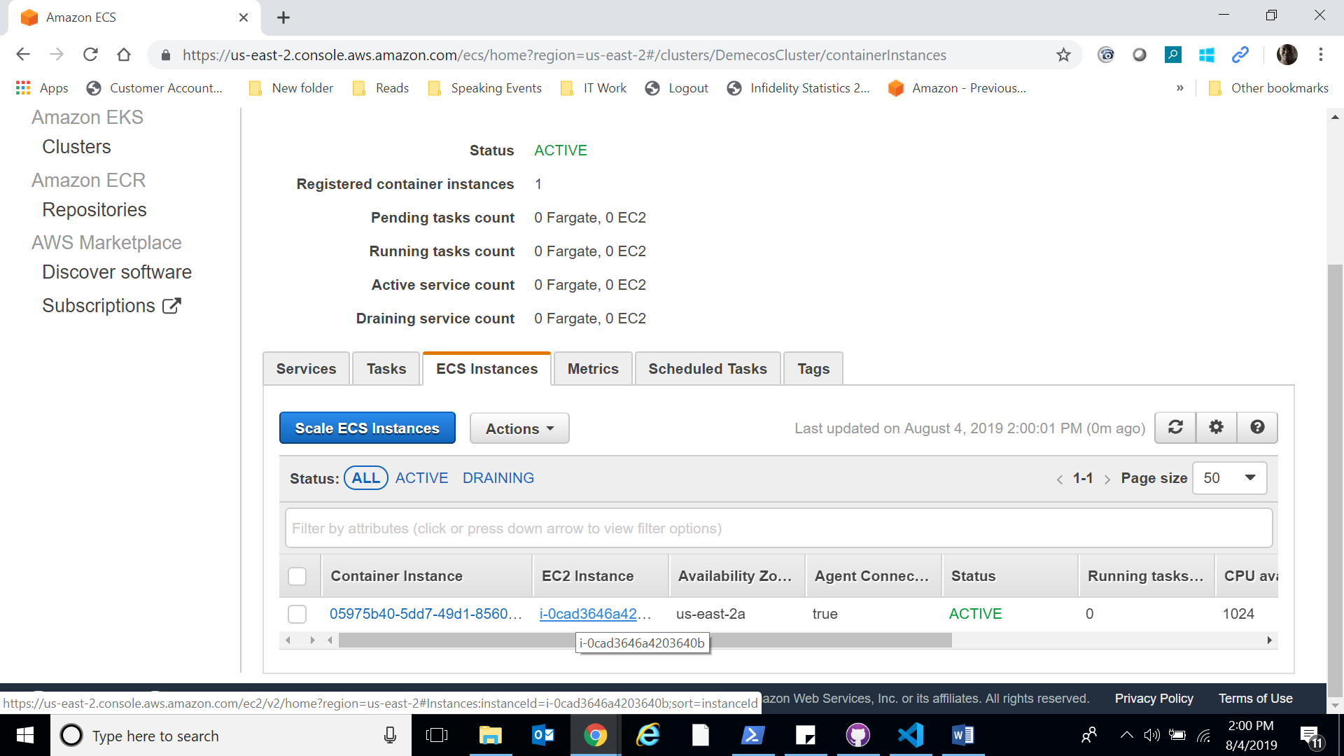

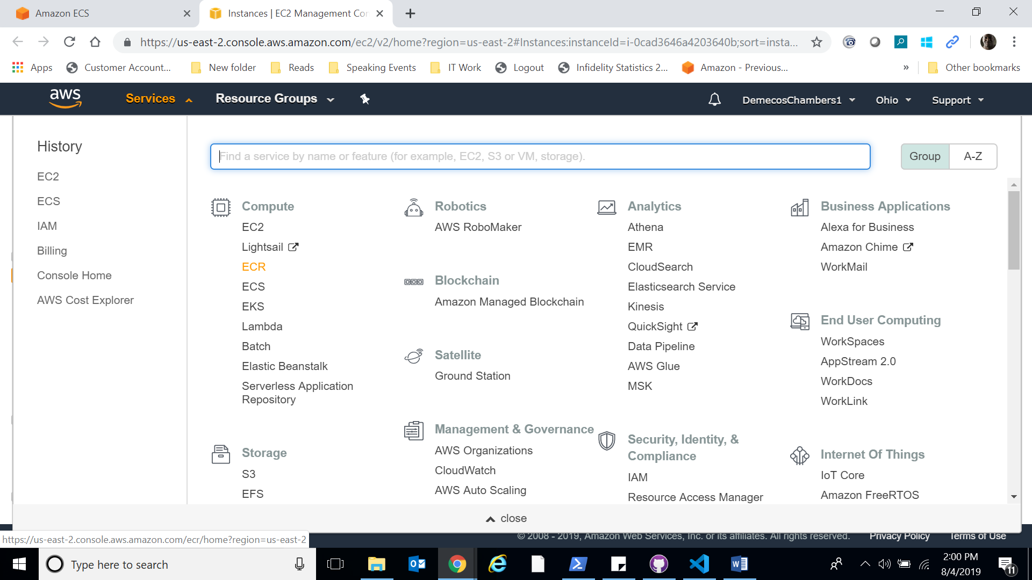

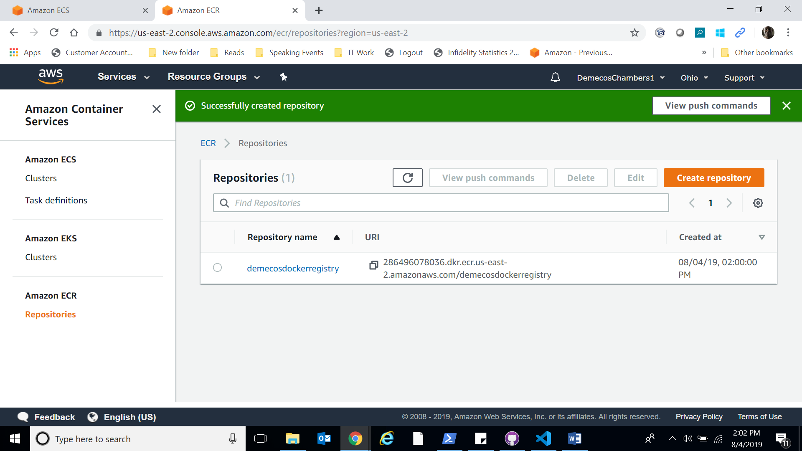

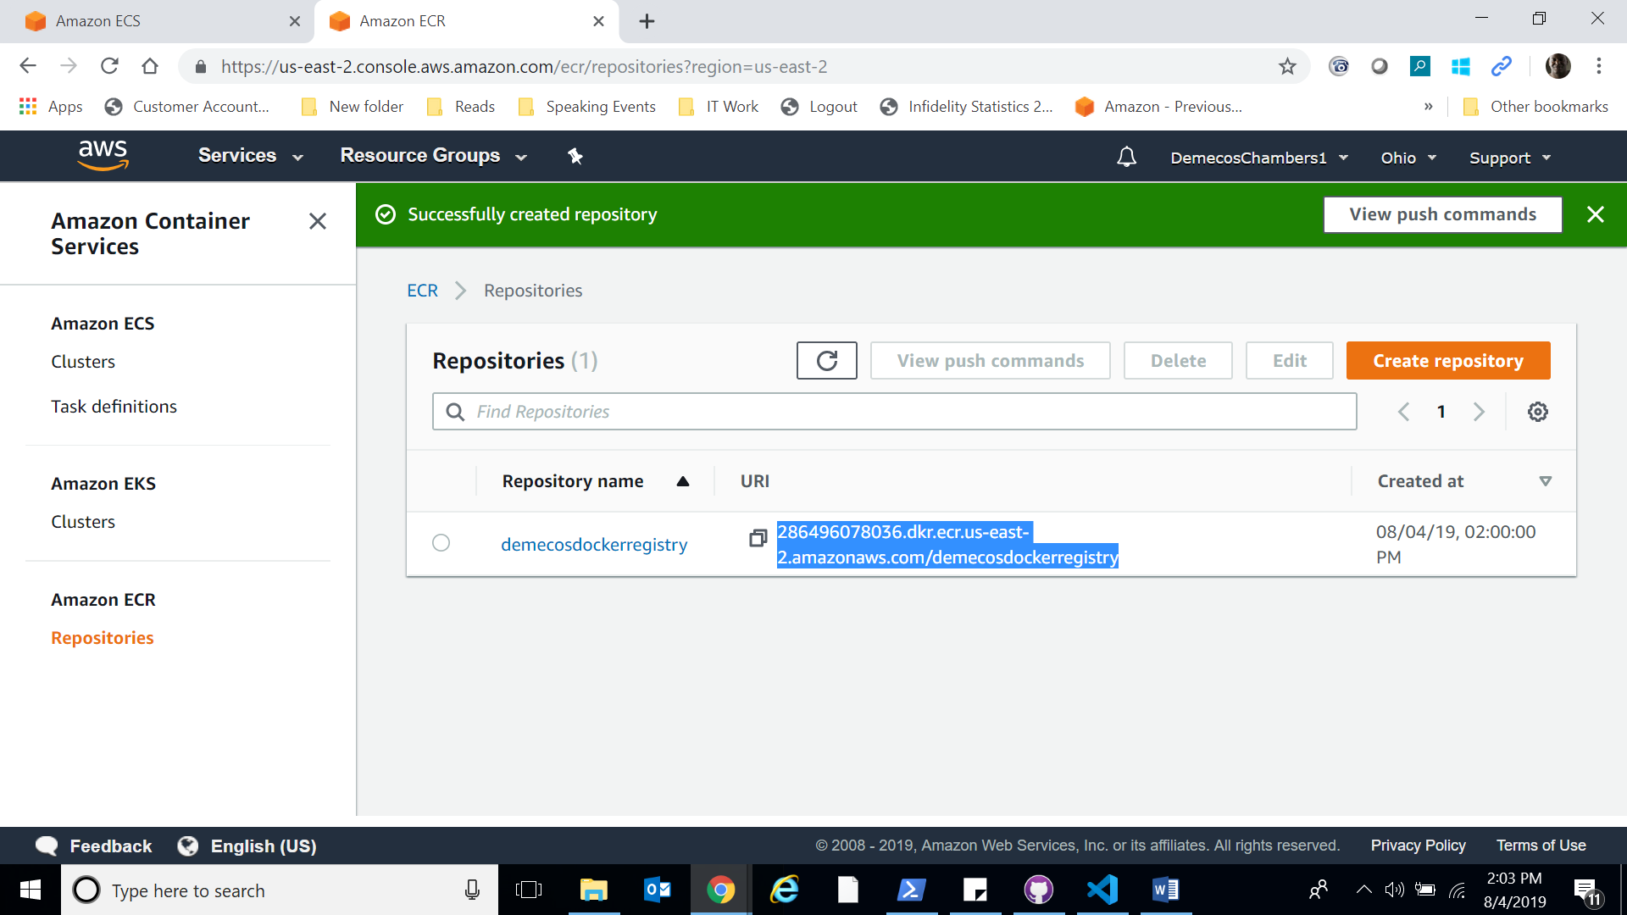

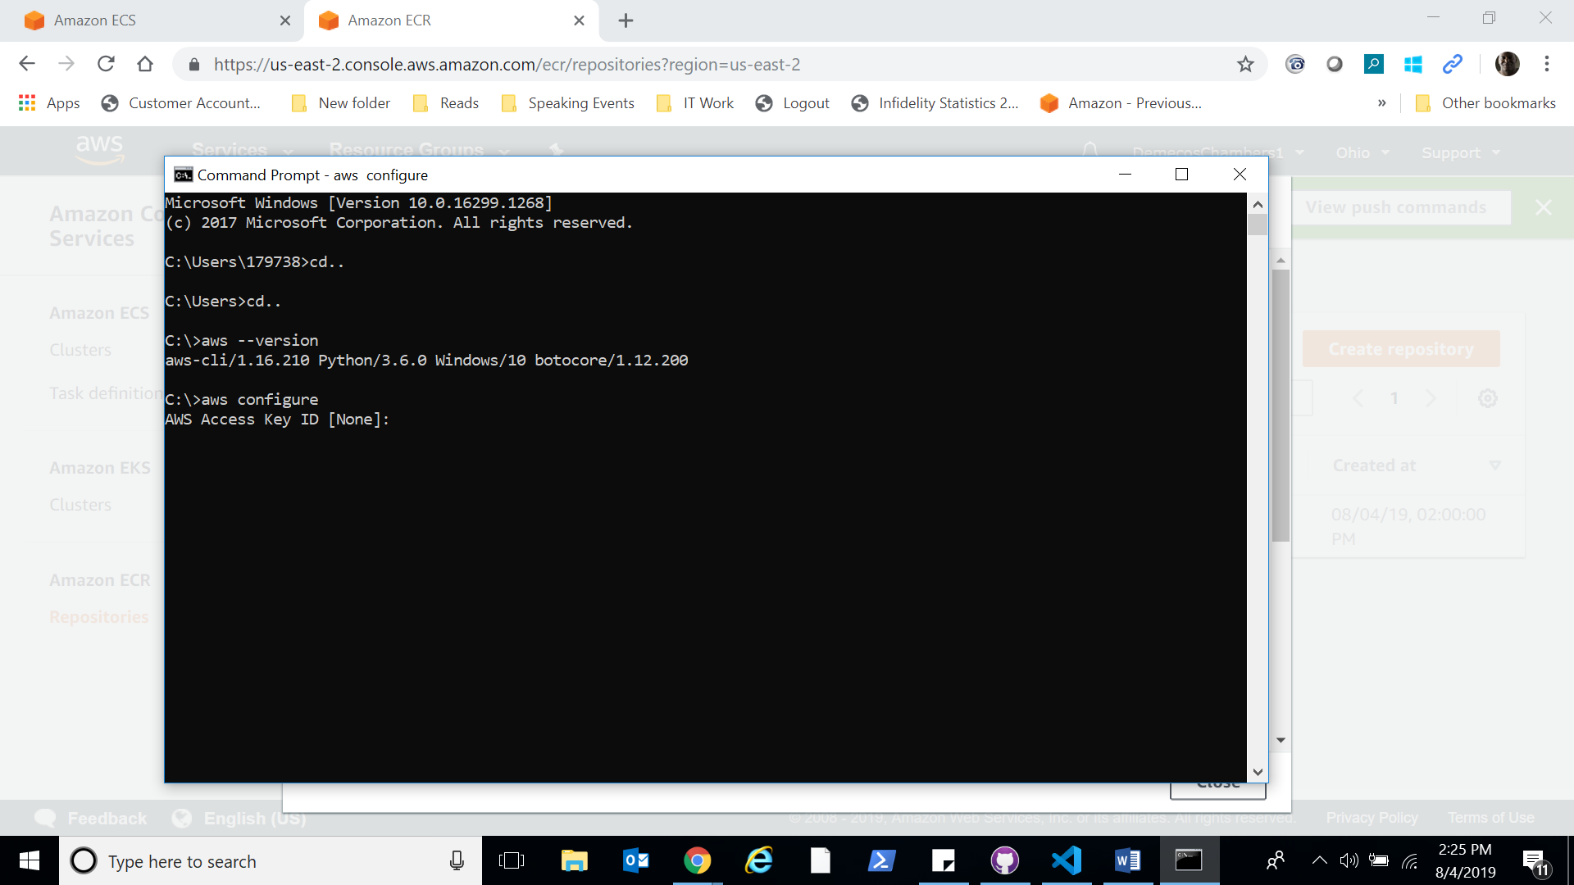

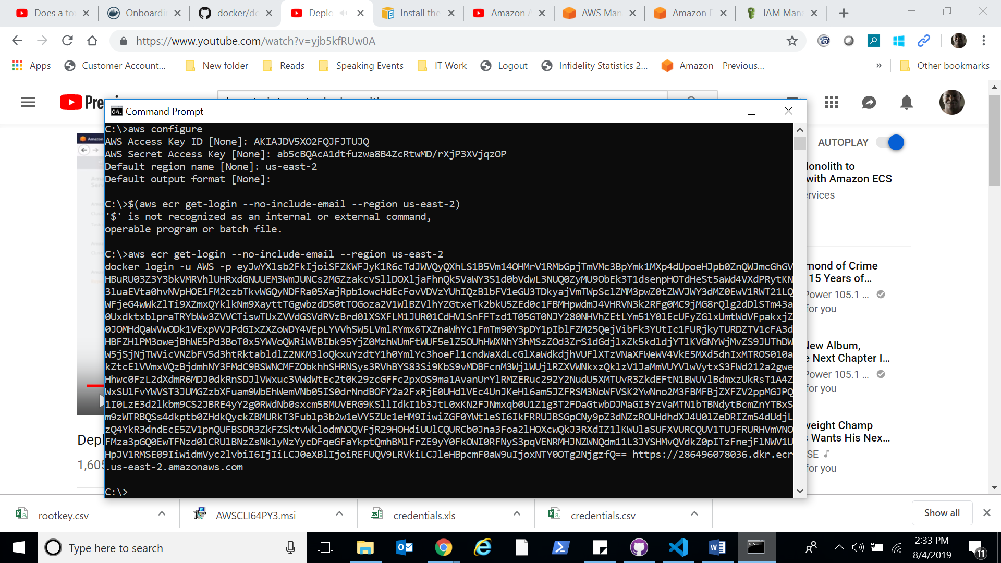

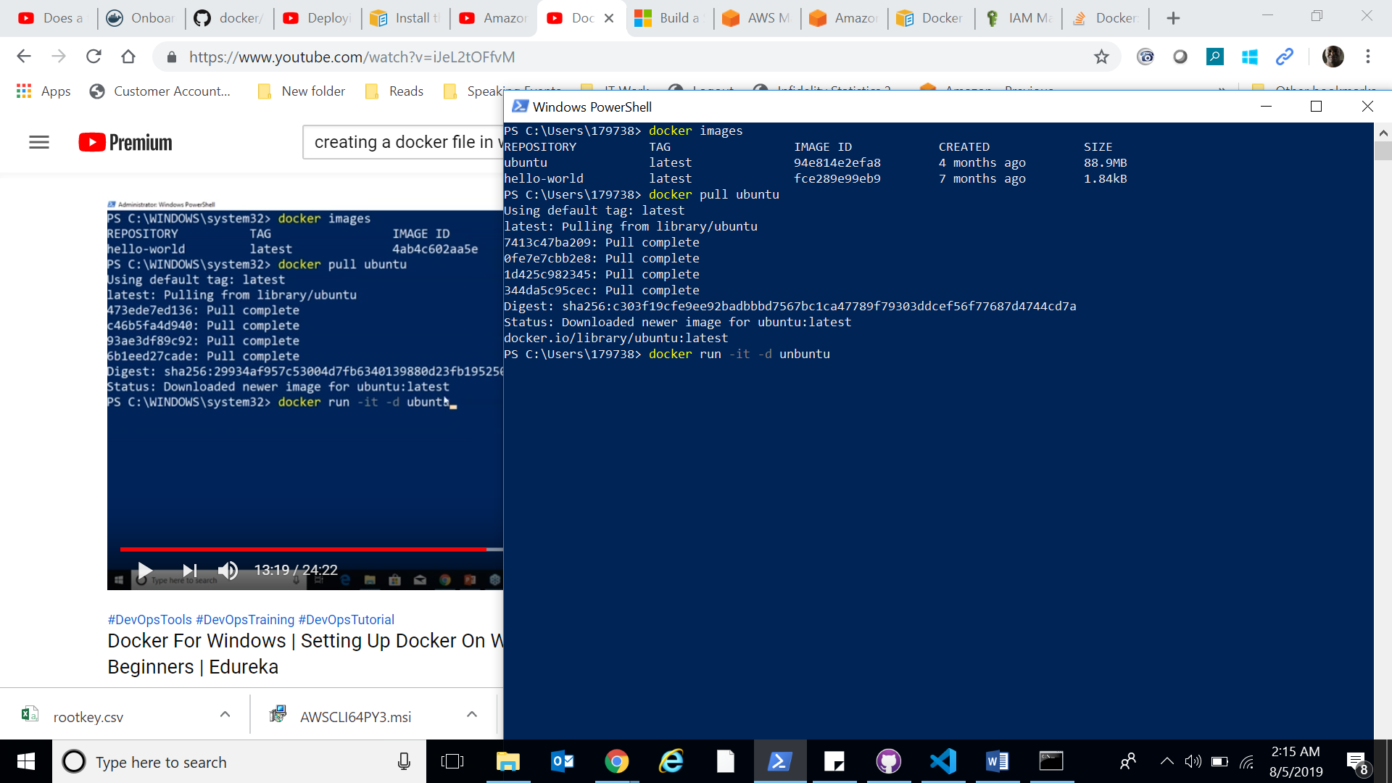

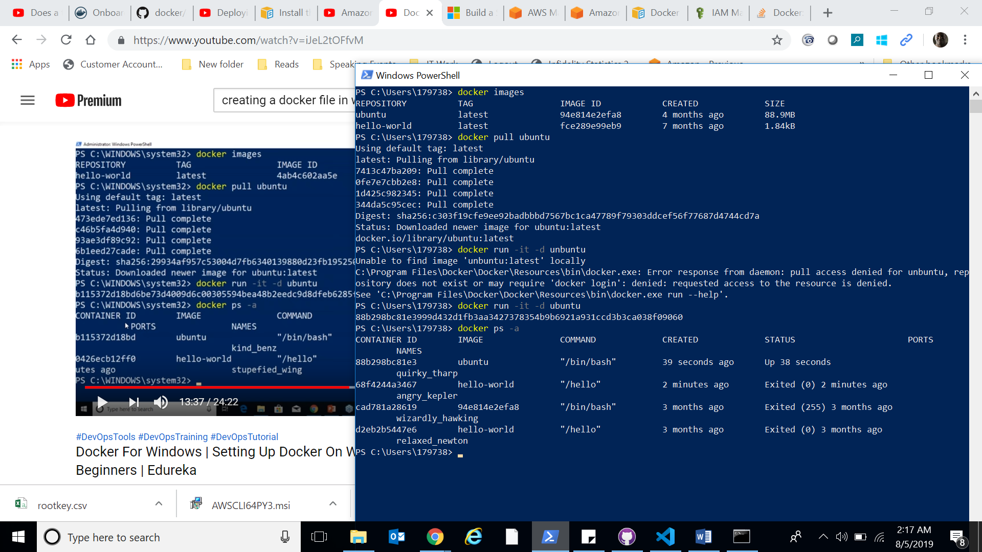

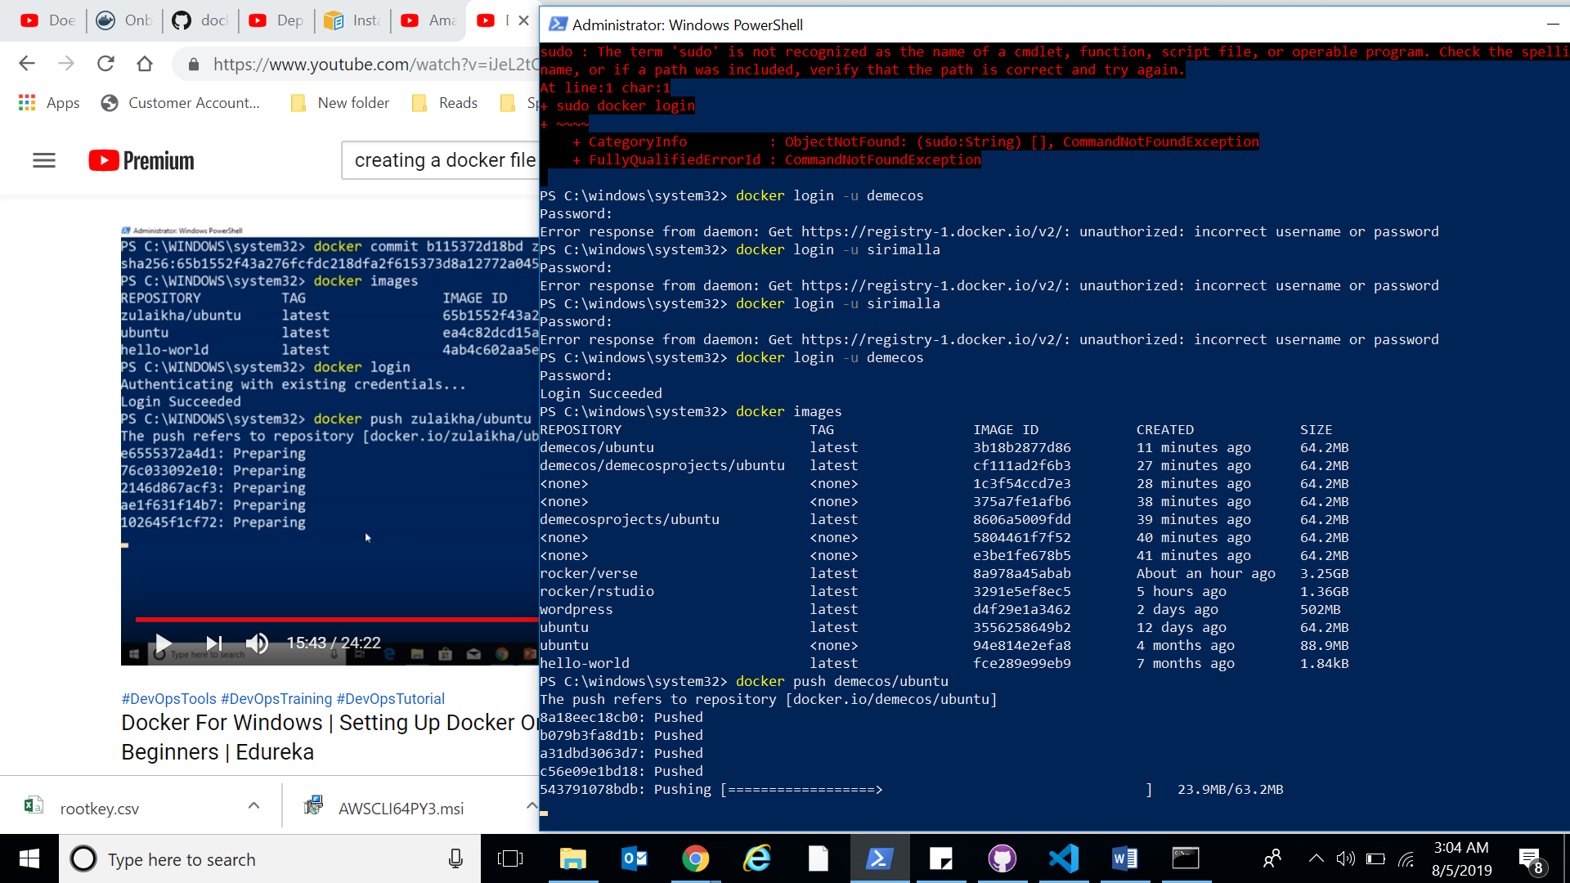

NOTE: This was VERY useful. I worked through a few bugs. I got stopped in 3 places. 1) Running hello world. Which i fixed by switching from windows container to linux container. 2) Creating a ubuntu image in my Docker repository. I fixed this by typing in commit, the image id then my repository name, hitting enter. Then running the docker images to show me the available images I created. Last 3) I got stuck pushing the image to my repository. I easily fixed it by using the docker login -u (usernamehere) and logging in successfully because my push kept getting denied. I ran that login and it said success then pushed the image and it allowed it to push through! This was great.

